**Scrape Instruction**

I need to scrap the datas from a HTML documents. The data are in a tabular format. There are about 4 to 5 different structures. Samples of the tables are recorded below.

I need all the rows extracted and place on a csv file in the correct order A to H, if there are documents without any of this Header (below). leave cell blank. Sample of each HTML documents & CSV file included in folder.

**Sample CSV File to record Extracted Data (Sample include in folder)**

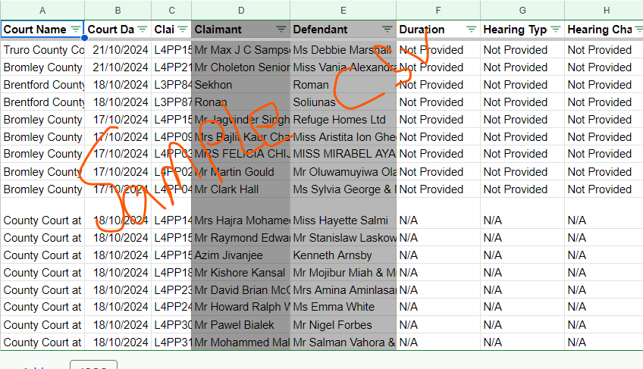

**Table 4 (Sample of each HTML documents included in folder)**

On table 4 & 4a html document type, Extract all rows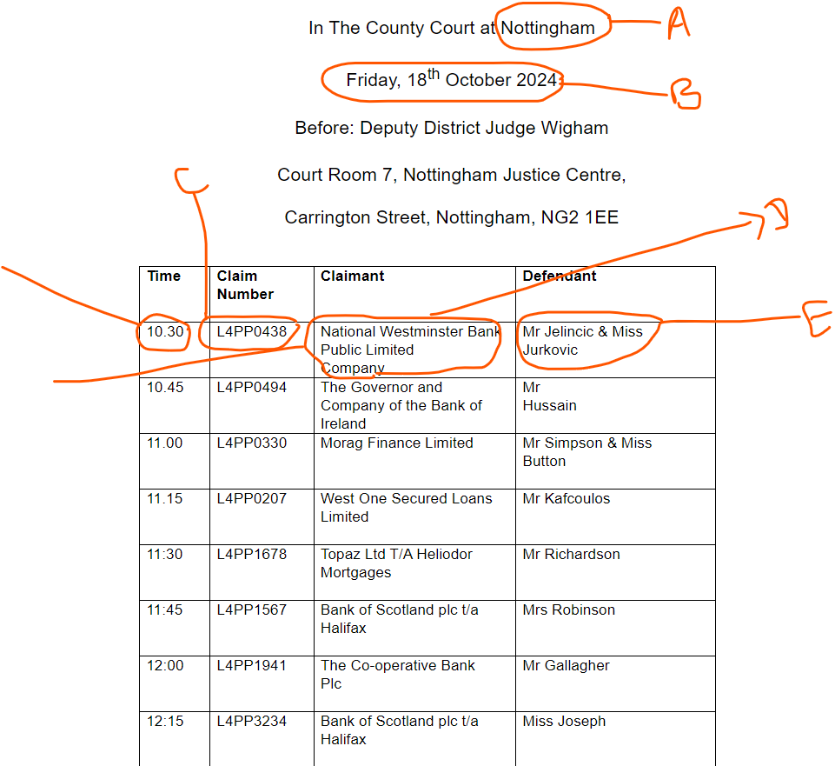

**Table 4a**

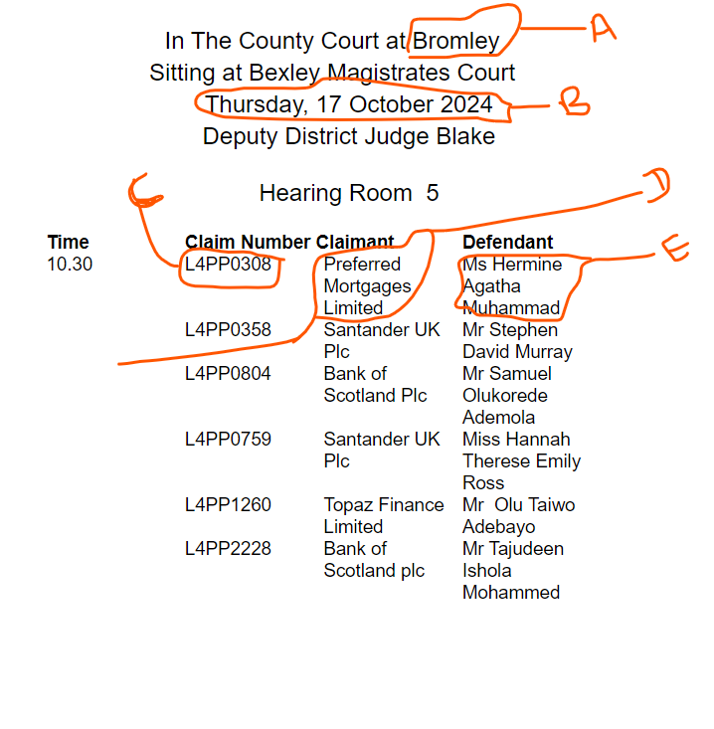

Table 5 & 6 are slightly similar but different table structure from Table 4 & 4a.

On the HTML documents Only scrape rows with **keyword “Possession”** not all rows.

On this document **Defendant & Claimant** are in the same box but separate with sign **“v” or “vs”**

**Table 5**

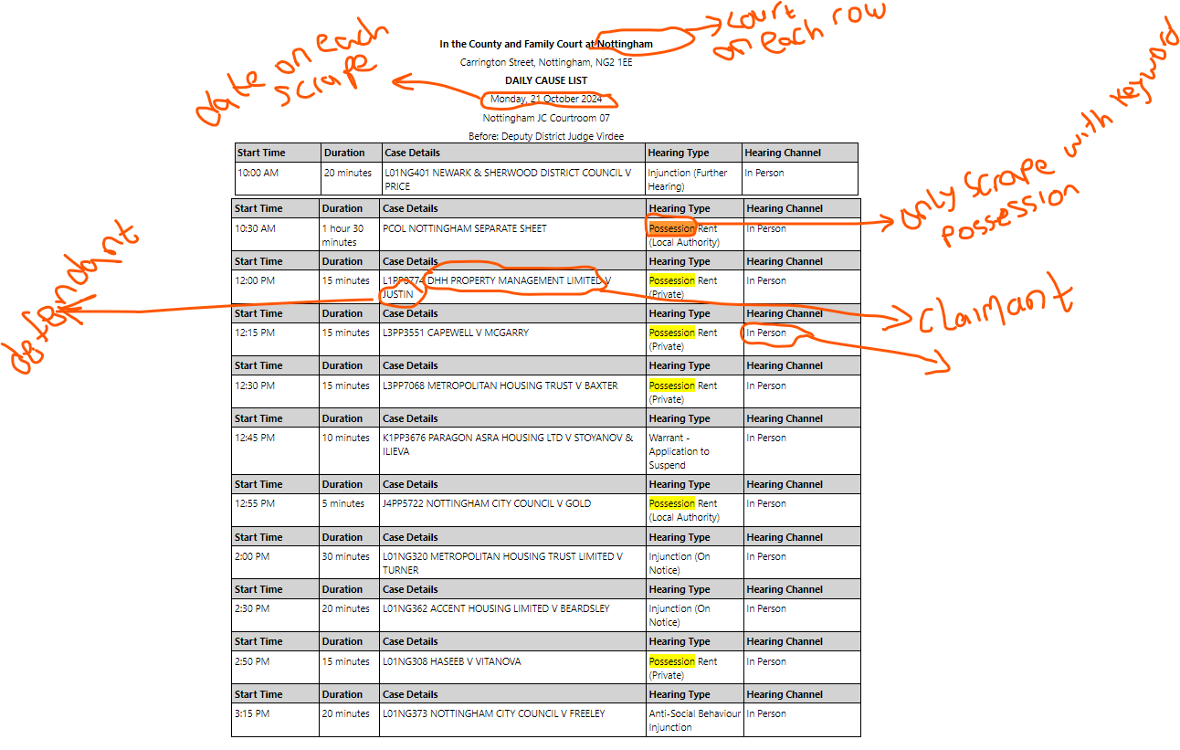

**Table 7**

